**Name:** Shreyash Banduji Chacharkar

Github link: <https://github.com/ShreyashChacharkar/EV_marketsegment>

**EV Market Segmentation:**

The Indian electric vehicle (EV) market has experienced rapid growth in recent years, driven by government incentives and increasing awareness of environmental sustainability. As one of the largest automobile markets in the world, India holds significant potential for the expansion of EV adoption, with a growing number of manufacturers introducing electric vehicles to cater to the increasing demand.

**Market Analysis:**

1. **Electric Vehicle Sales Growth**: Electric vehicle (EV) sales in India remained relatively stagnant until 2016. After that, there was a significant uptick in growth, with a remarkable Compound Annual Growth Rate (CAGR) of 40.3%.

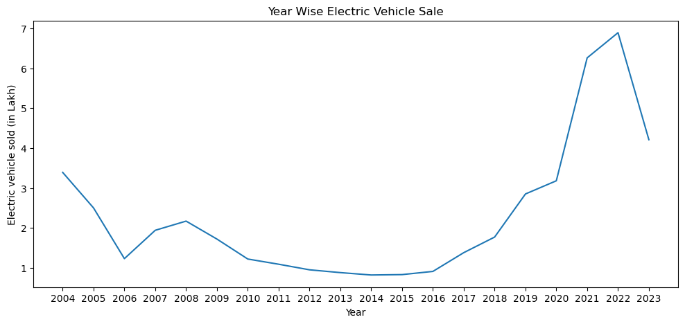

Fig 1: Year wise Electric vehicle production

1. **Seasonal Sales Peaks:** Notably, the highest EV sales occur typically in the months of January, February, March, July, and September. Mainly due Indian customer behaviour at festival.

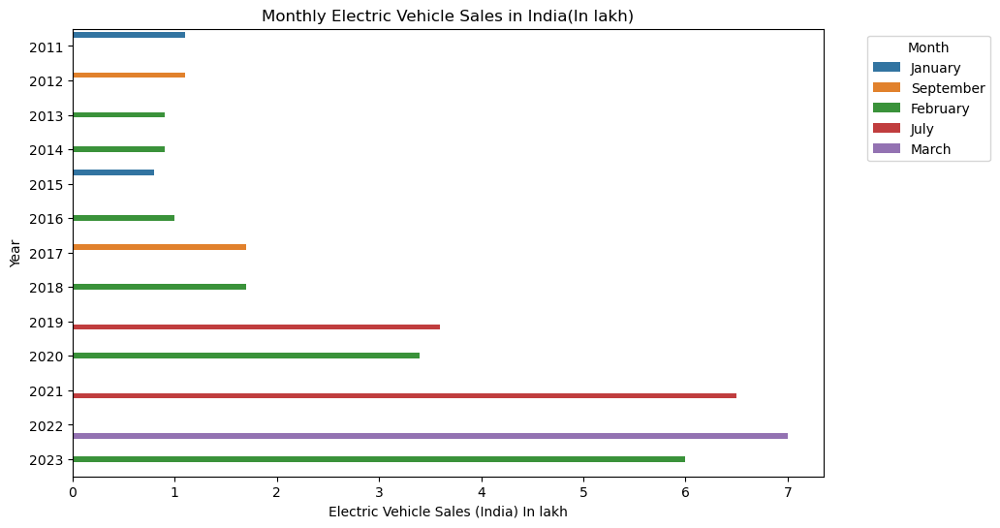

Fig 2 . Electric vehicle sales

1. **Government's FAME Scheme:** The Government of India initiated the Faster Adoption and Manufacturing of (Hybrid &) Electric Vehicles (FAME) scheme with the aim of promoting the widespread adoption of electric and hybrid vehicles. FAME II, launched in April 2019 and designed to span three years, involved a substantial allocation of INR 10,000 crore (approximately USD 1.4 billion) to incentivize the production and adoption of EVs.
2. **Charging Infrastructure Development:** The government also dedicated funds to bolster the development of EV charging infrastructure throughout the country. This endeavor encompassed the establishment of public charging stations, with a particular focus on urban areas and highway networks. The allocated amount for charging infrastructure evolved on a yearly basis.
3. **Incentives and Subsidies:** To stimulate the EV ecosystem, the government extended subsidies and incentives to both EV manufacturers and buyers. These incentives comprised reduced GST rates, income tax benefits, as well as subsidies applicable to electric two-wheelers, three-wheelers, and four-wheelers.
4. **Significance of the Delhi-Kolkata Freight Corridor:** The Delhi-Kolkata freight corridor is of paramount importance within India's transportation landscape, facilitating the efficient movement of goods and commodities between the northern and eastern regions of the country. This corridor plays a critical role in the logistics and supply chain industry.

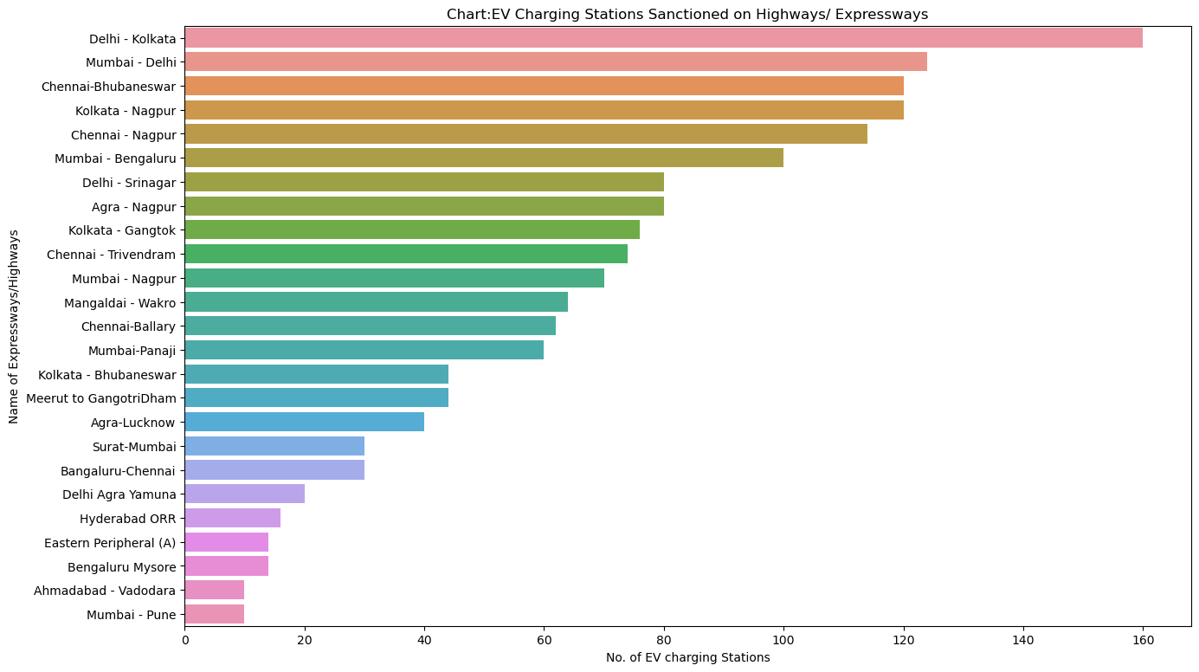

Fig3. Charging Station deployment at Expressway and Highway

1. **Strategic Charging Infrastructure Deployment**: The strategic deployment of a substantial number of EV charging stations along this corridor aligns harmoniously with the government's overarching objective of promoting electric mobility, particularly in the commercial and freight sectors. This is in response to the development and deployment of electric trucks and other heavy-duty vehicles designed to curtail emissions and operational expenses within the logistics industry.
2. **Enhanced Connectivity Through Charging Stations:** The establishment of charging stations in key cities along this corridor, including Delhi, Chennai, Kolkata, and Nagpur, ensures that electric freight vehicles possess the necessary access to charging infrastructure at pivotal transit points. This, in turn, augments the overall connectivity and viability of electric vehicles for long-haul transportation.
3. **Economic Advantages:** The promotion of electric freight vehicles carries inherent economic advantages. Electric vehicles, when compared to traditional diesel-powered counterparts, boast lower operating costs. This, in effect, results in cost savings for businesses engaged in logistics and transportation, subsequently fostering economic growth at a broader scale.

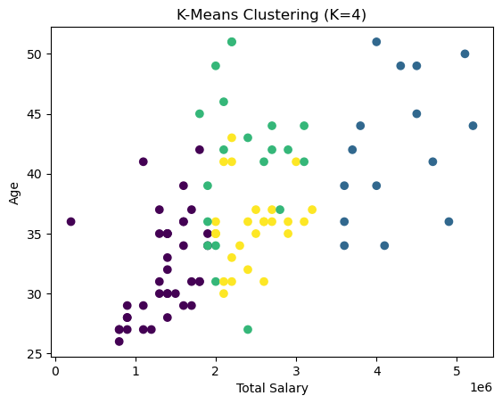

Fig 4 Indian Customer Segmentation

Conclusion:

* Maximum no. of charging stations are installed at Delhi-Kolkata i.e. Nearly 160.
* Chenni, Kolkata, Nagpur, Delhi are top cities through which highway pass which has highest no. of charging station.
* EV sales growth was stagnant until 2016 after that it grows significantly with 40.3% CAGR
* Maximum Sales can be observed in either January, February, March or July, September month.